***PAAREES PERFUMES***

***DAVIDOFF***

***FOR UNISEX***

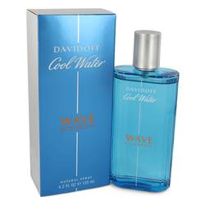

# *Cool Water wave*

***Description:***

Cool Water Wave by Davidoff Cologne. In 2017, Cool Water Wave cologne was released. It brings many aquatic and woody accords around a man’s pulse points. The top notes of the composition include sea notes in addition to Sichuan pepper and grapefruit. The heart consists of juniper and birch leaf. It ends with a resilient base made up of sandalwood and patchouli.  
  
This fragrance was developed by Jean Jacques, Antoine Lie and Francis Kurkdjian in collaboration with the fragrance house, Davidoff. This company is based out of Switzerland and is predominantly known for manufacturing fashionable accessories. The brand is known for its first-class leather goods, writing utensils and watches. Regardless of what product the company is working on, whether it is a new fragrance of a watch, it only uses the finest materials. The first fragrance from this company launched in 1984, and over the last couple of decades, the brand has managed to release several dozen incredible colognes.